Exercise: REST Services and AJAX
Problems for exercises and homework for the "JavaScript Applications" course @ SoftUni. Submit your solutions in the SoftUni Page - https://softuni.bg/trainings/2347/js-apps-july-2019#lesson-11778

Bus Stop
Write a JS program that displays arrival times for all buses by a given bus stop ID when a button is clicked. Use the skeleton from the provided resources.
When the button with ID 'submit' is clicked, the name of the bus stop appears and the list bellow gets filled with all the buses that are expected and their time of arrival. Take the value of the input field with id 'stopId'. Submit a GET request to:
http://localhost:3000/businfo/{stopId} - if you use the provided server from the resourses where you shoud add buss stop data, or use the ready and full database from these url :
https://judgetests.firebaseio.com/businfo/{stopId}.json
Replace the highlighted part with the correct value and parse the response. You will receive a JSON object in the format:
stopId: {
name: stopName,
buses: { busId: time, … }
}
Place the name property as text inside the div with ID 'stopName' and each bus as a list item with text:
"Bus {busId} arrives in {time}"
Replace all highlighted parts with the relevant value from the response. If the request is not successful, or the information is not in the expected format, display "Error" as stopName and nothing in the list. The list should be cleared before every request is sent.

Examples
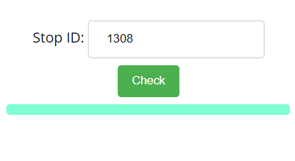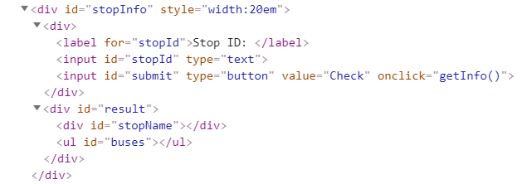
When the button is clicked, the results are displayed in the corresponding elements:
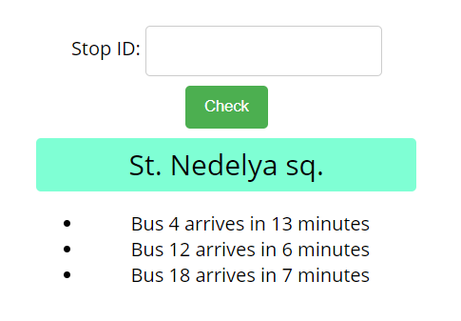
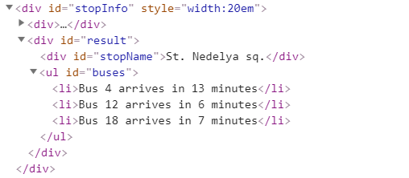
If an error occurs, the stop name changes to Error:
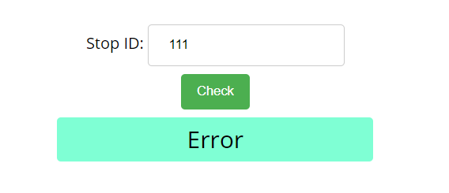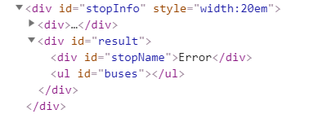

Hints
The webhost will respond with valid data to IDs 1287, 1308, 1327 and 2334.

Bus Schedule
Write a JS program that tracks the progress of a bus on it’s route and announces it inside an info box. The program should display which is the upcoming stop and once the bus arrives, to request from the server the name of the next one. Use the skeleton from the provided resources.

The bus has two states – moving and stopped. When it is stopped, only the button “Depart” is enabled, while the info box shows the name of the current stop. When it is moving, only the button “Arrive” is enabled, while the info box shows the name of the upcoming stop. Initially, the info box shows "Not Connected" and the "Arrive" button is disabled. The ID of the first stop is "depot".
When the "Depart" button is clicked, make a GET request to the server with the ID of the current stop to address
http://localhost:3000/schedule/{currentId} - if you use the provided server from the resourses where you shoud add buss schedule data, or use the ready and full database from the next url :
https://judgetests.firebaseio.com/schedule/{currentId}.json
Replace the highlighted part with the relevant value. As a response, you will receive a JSON object in the following format:
stopId {
name: stopName,
next: nextStopId
}
Update the info box with the information from the response, disable the “Depart” button and enable the “Arrive” button. The info box text should look like this (replace the highlighted part with the relevant value):
Next stop {stopName}
When the "Arrive" button is clicked, update the text, disable the “Arrive” button and enable the “Depart” button. The info box text should look like this (replace the highlighted part with the relevant value):
Arriving at {stopName}
Clicking the buttons successfully will cycle through the entire schedule. If invalid data is received, show "Error" inside the info box and disable both buttons.

Examples
Initially, the info box shows “Not Connected” and the arrive button is disabled.
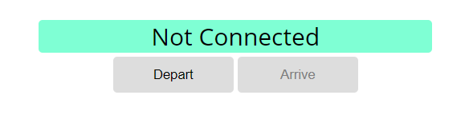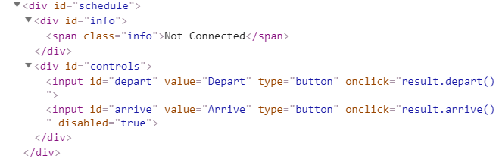

When Depart is clicked, a request is made with the first ID. The info box is updated with the new information and the buttons are changed: 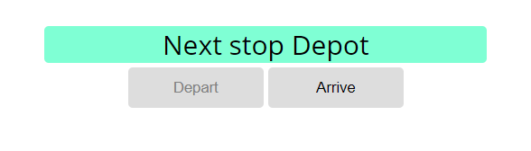
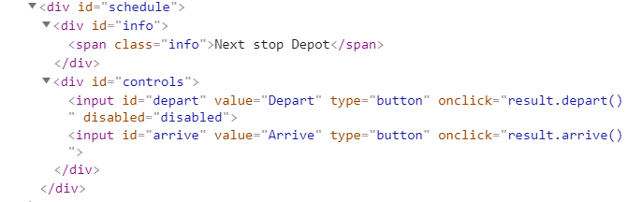

Clicking Arrive, changes the info box and swaps the buttons. This allows Depart to be clicked again, which makes a new request and updates the information:
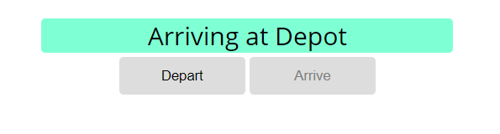
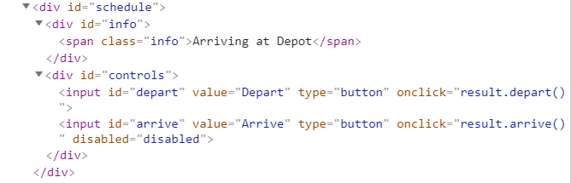

* Phonebook
Write a JS program that can load, create and delete entries from a Phonebook. You will be given an HTML template to which you must bind the needed functionality.
Use the skeleton from the provided resources.
When the [Load] button is clicked, a GET request should be made to the server to get all phonebook entries. Each received entry should be in a li inside the ul with id="phonebook" in the following format with text "<person>: <phone> " and a [Delete] button attached. Pressing the [Delete] button should send a DELETE request to the server and delete the entry. The received response will be an object in the following format:
{<key>:{person:<person>, phone:<phone>}, <key2>:{person:<person2>, phone:<phone2>,…} where <key> is an unique key given by the server and <person> and <phone> are the actual values.
When the [Create] button is clicked, a new POST request should be made to the server with the information from the Person and Phone textboxes, the Person and Phone textboxes should be cleared and the Phonebook should be automatically reloaded (like if the [Load] button was pressed).
The data sent on a POST request should be a valid JSON object, containing properties person and phone. Example format:
{
"person": "<person>",
"phone": "<phone>"
}
The url to which your program should make requests is:
'http://localhost:3000/phonebook'
GET and POST requests should go to http://localhost:3000/phonebook, while DELETE requests should go to http://localhost:3000/phonebook/<key>, where <key> is the unique key of the entry (you can find out the key from the key property in the GET request)

Screenshots:
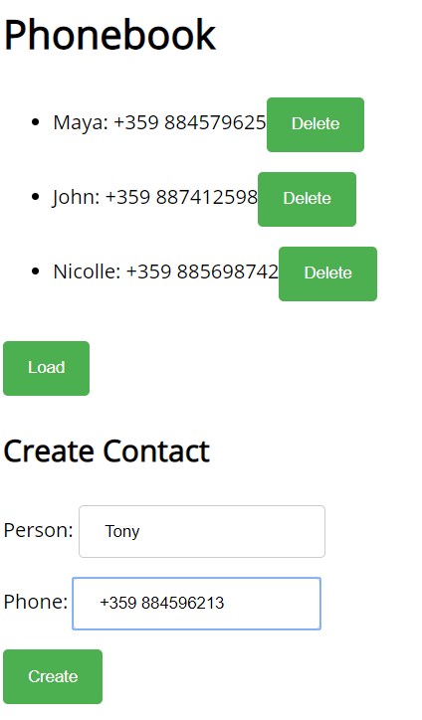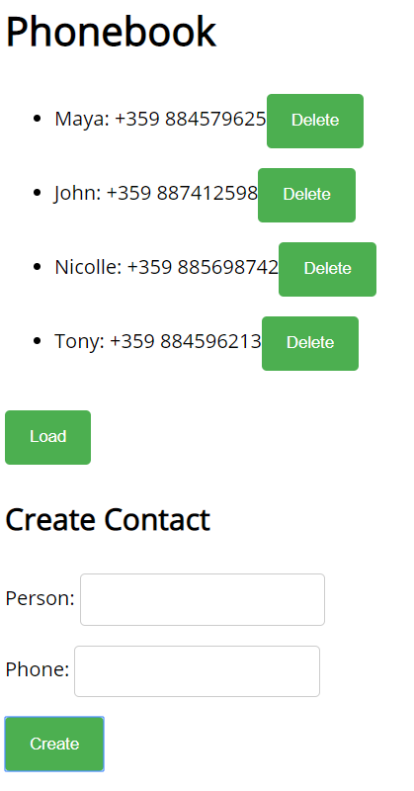

* Messenger
Write a JS program that records and displays messages. The user can post a message, supplying a name and content and retrieve all currently recorded messages.
Use the skeleton from the provided resources
Firebase url for the requests - http://localhost:3000/messenger
When [Send] button is clicked you should create a new object and send a post request to the firebase url. Use the following message structure:
{
author: authorName,
content: msgText,
}
The key associated with each message object is not important - when making a POST request with the message object as parameter, Firebase will automatically assign a random key.
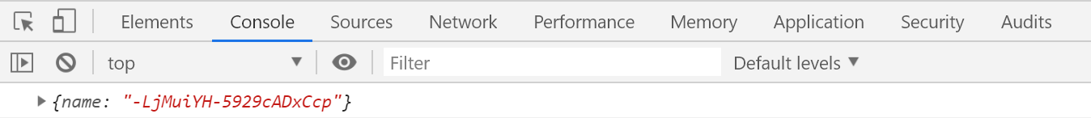
If you click over [Refresh] button you should get all messages with GET request and display them into the textarea. Use the following message format:
"{author}: {message}"

Examples
